**Assignment**

**Date : 29-12-23**

**Creating an azure databricks workspace and creating cluster**

1.Select the existing azure databricks workspace or create a new workspace.

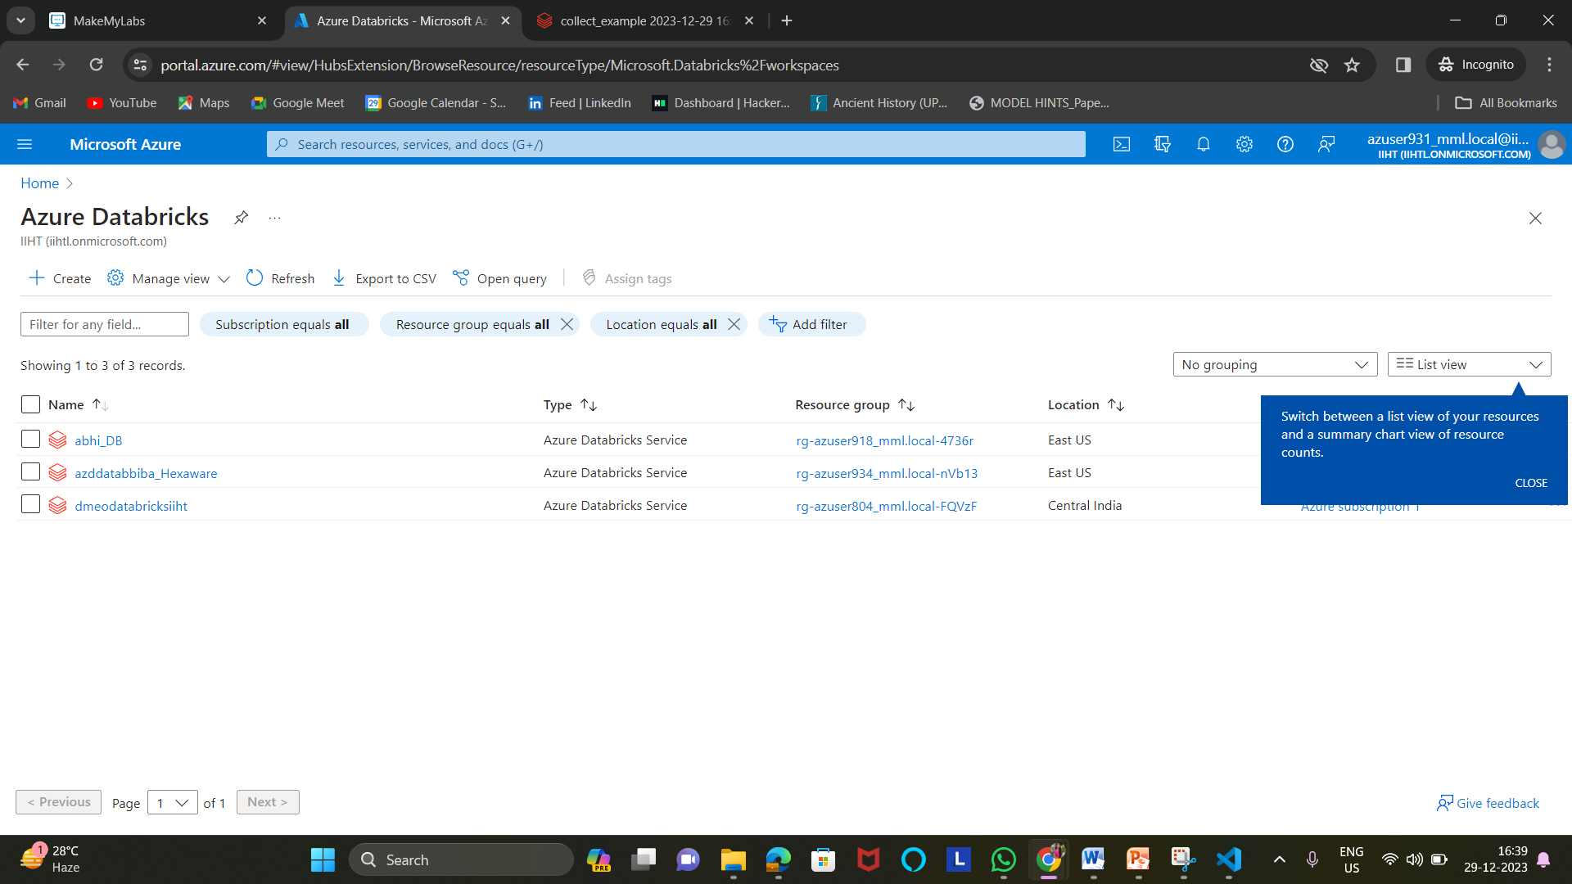

2. After choosing the workspace cleck on “ Launch workspace”.

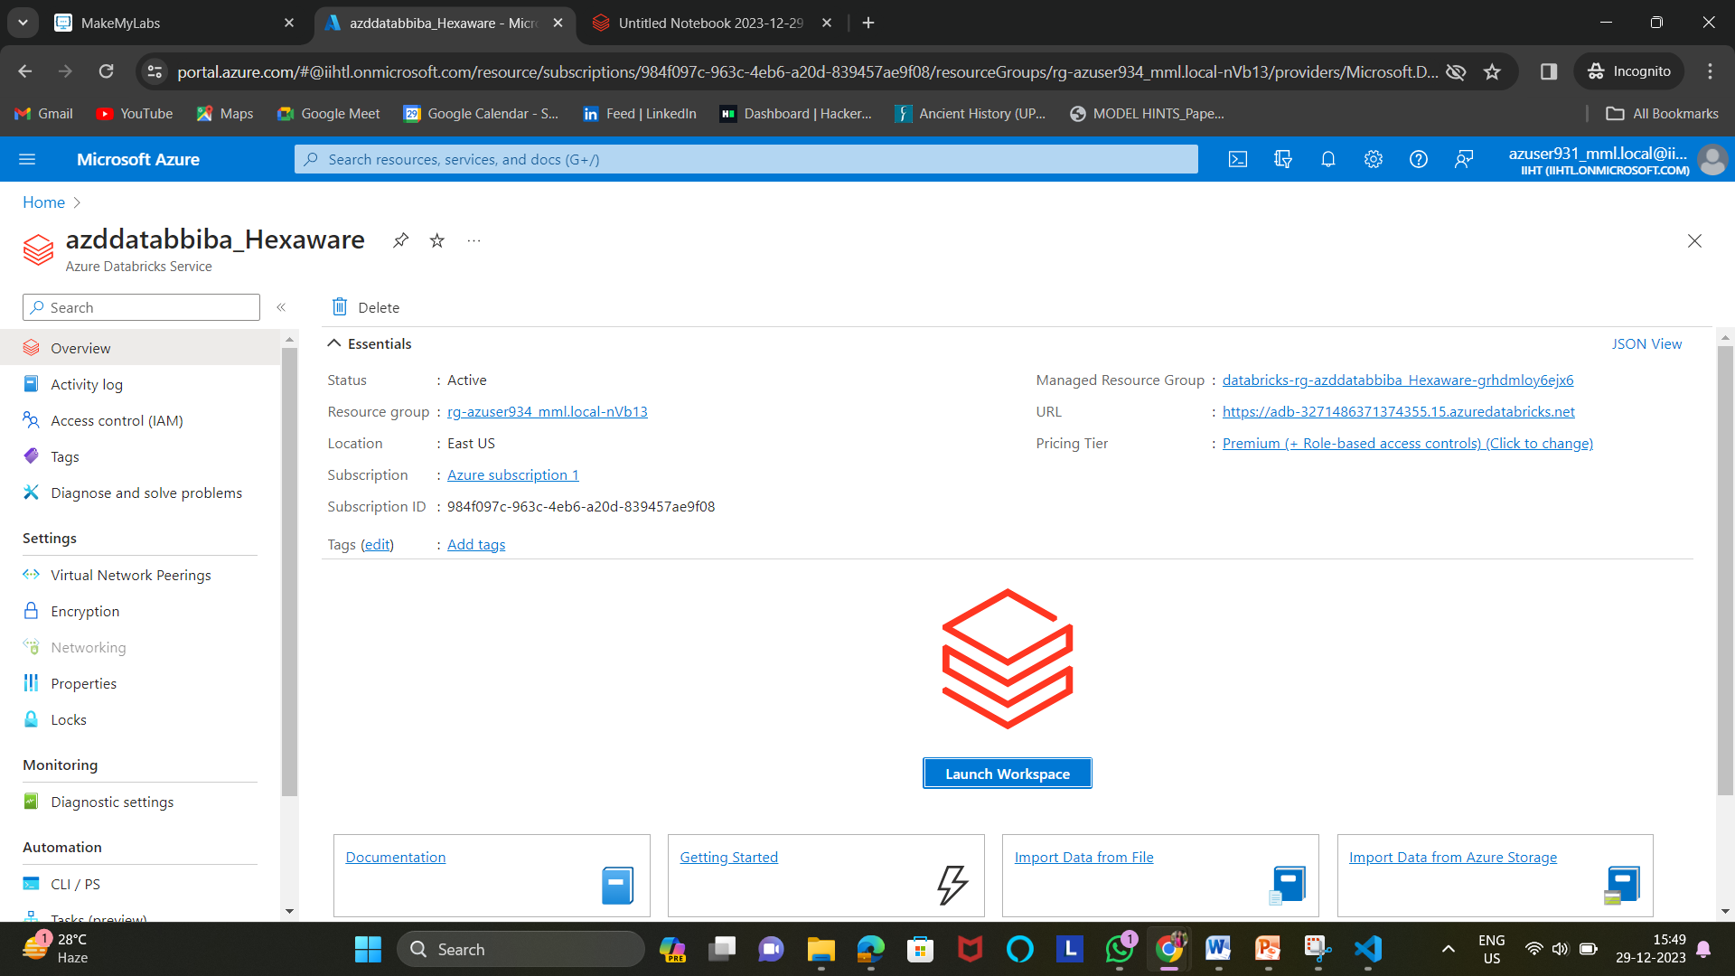

3. It will redirected to this page. Select “compute”

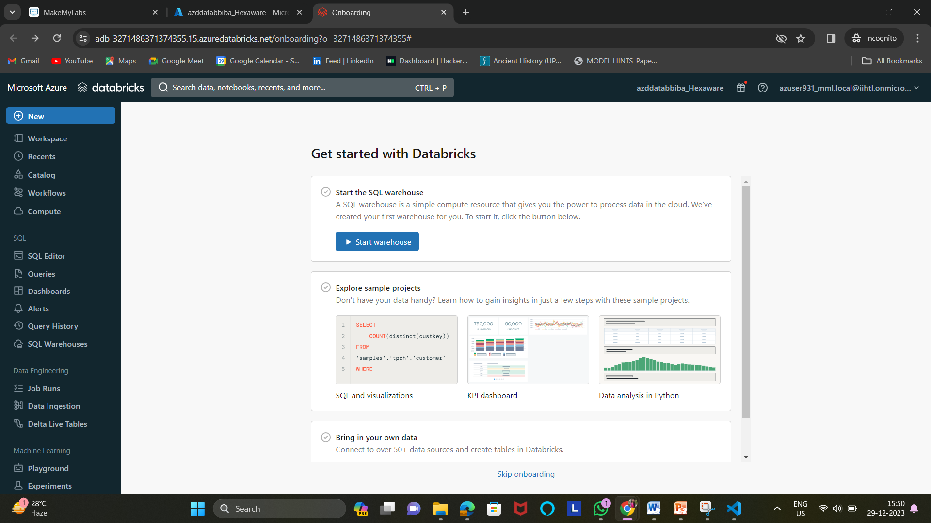

4. Choose the available cluster or we can create our own cluster

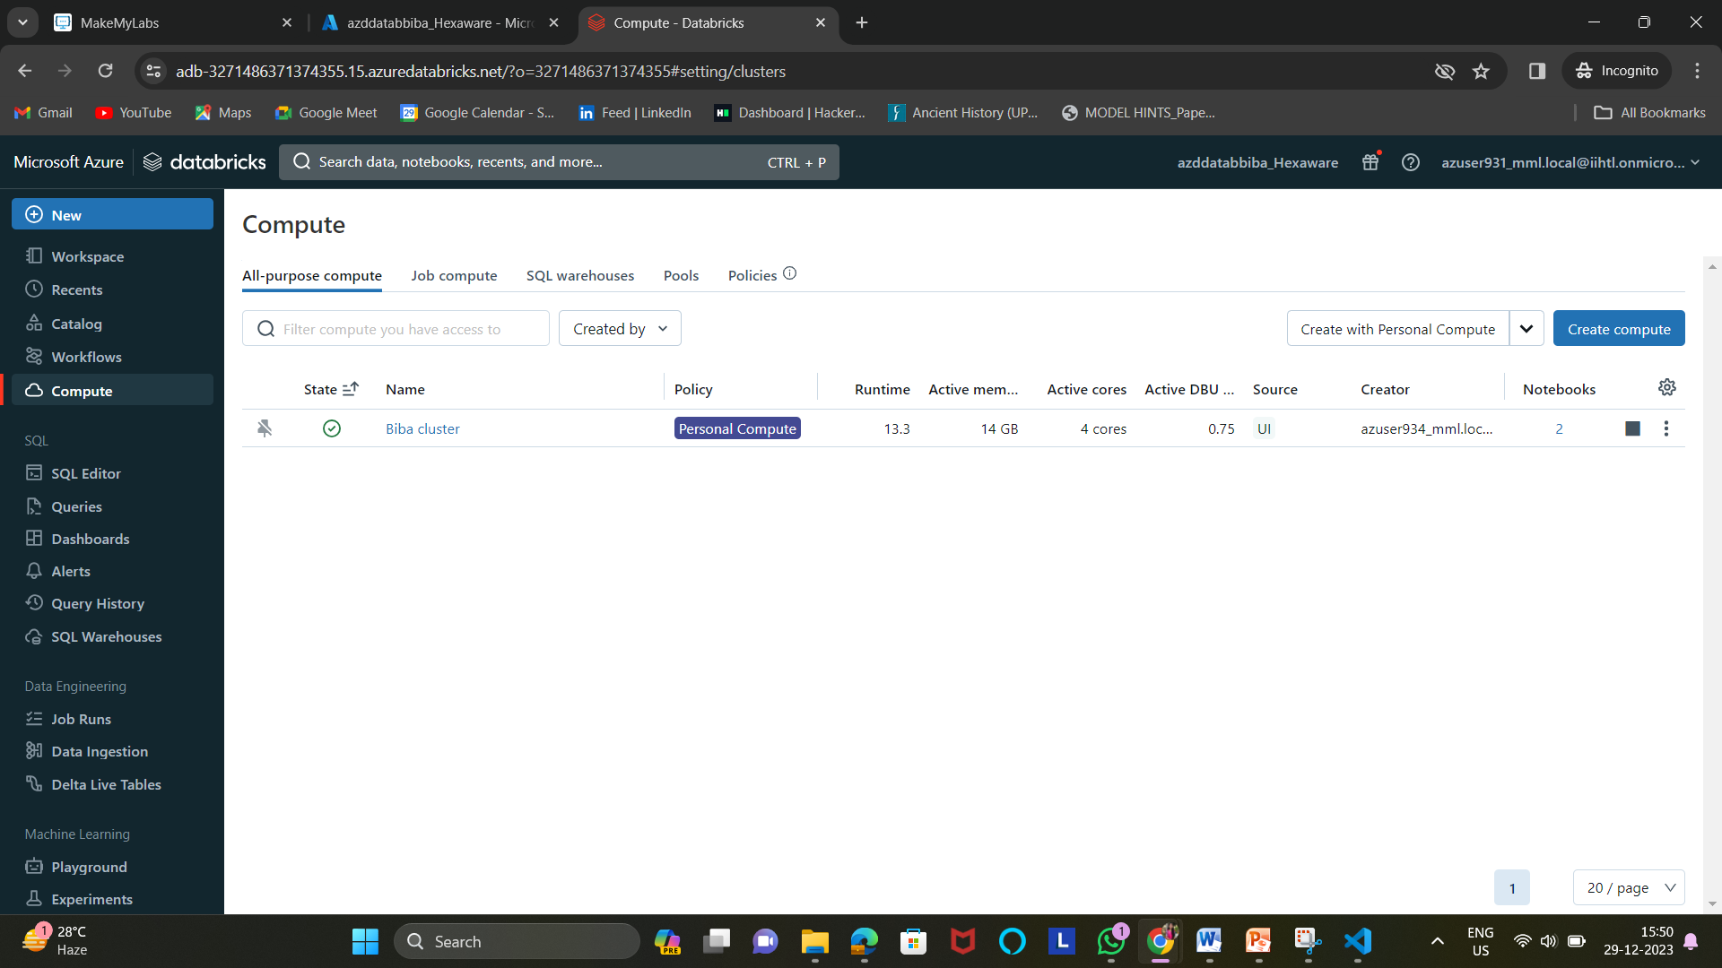

5. Go to New option and Select Notebook.

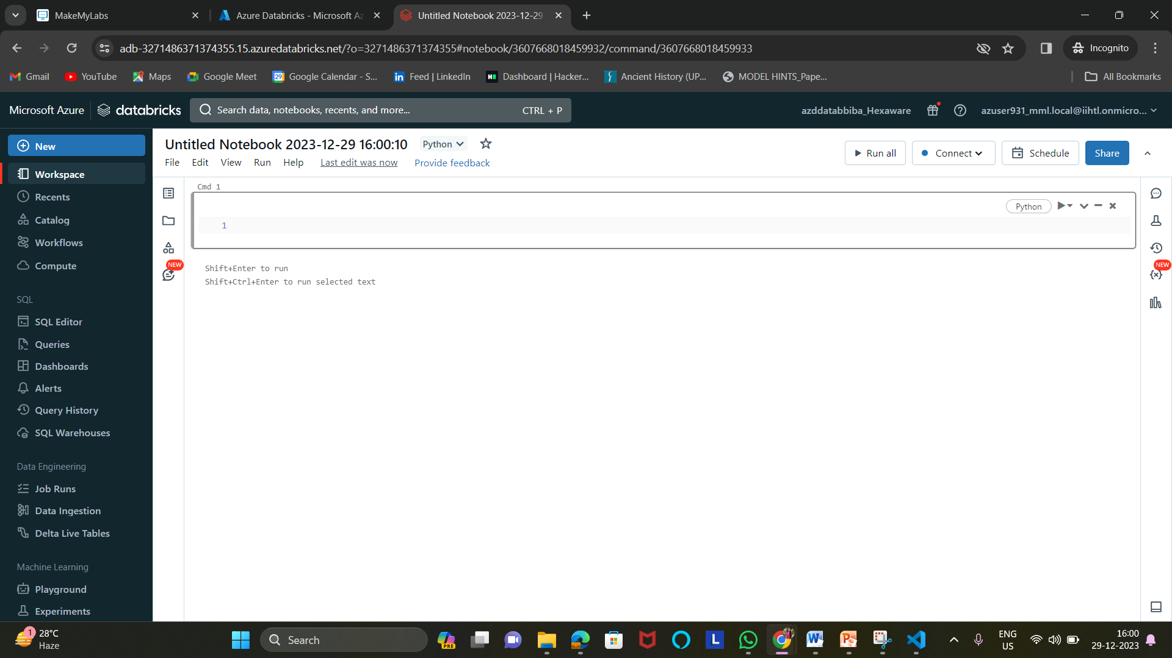

6. Write a code in the cell and connect to the created cluster and run the code

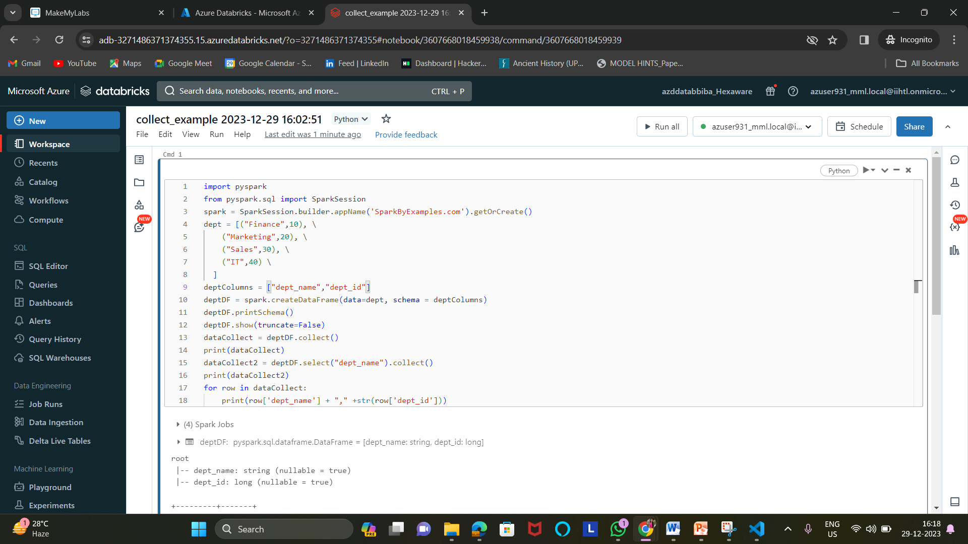

7.Displays the output

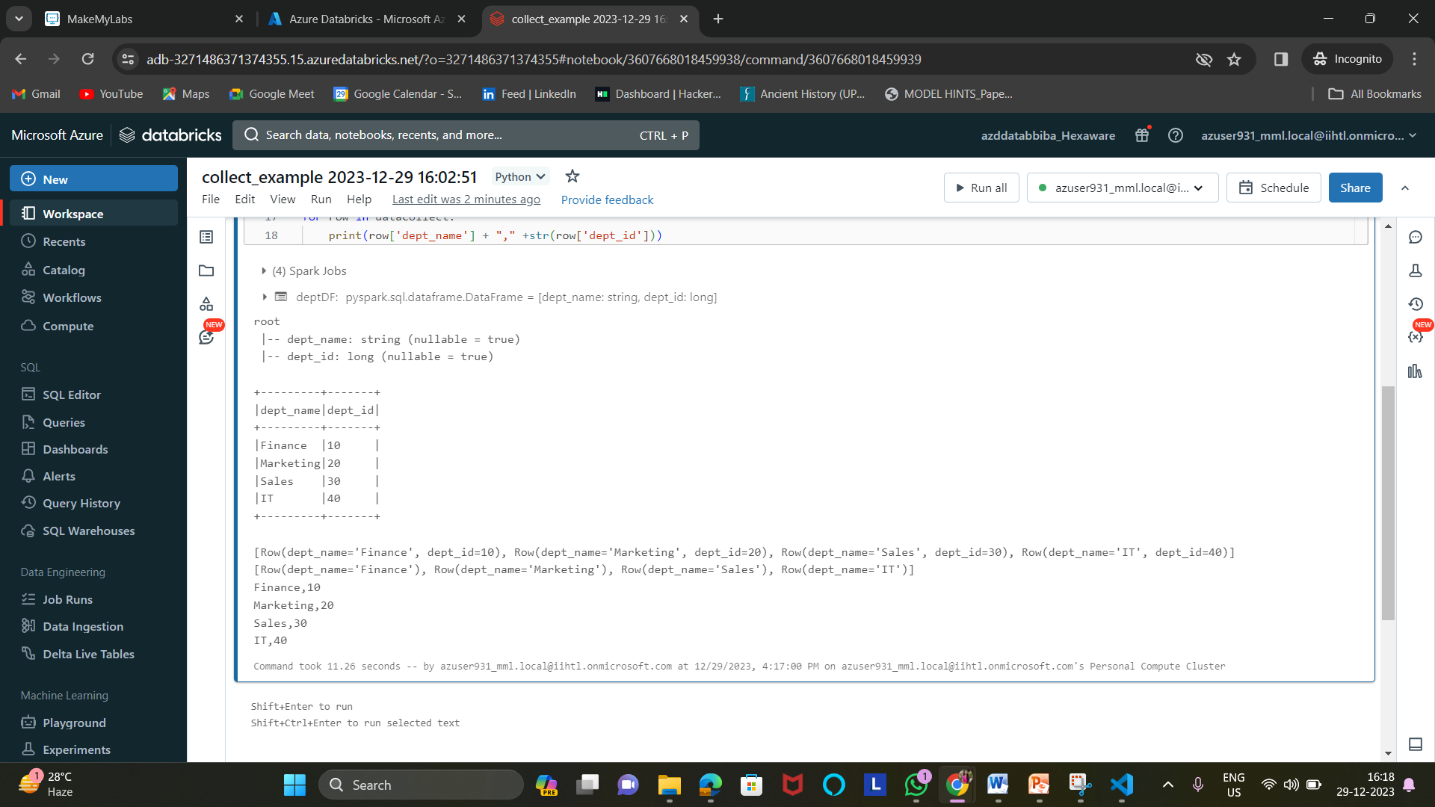

8.Aggregate operations

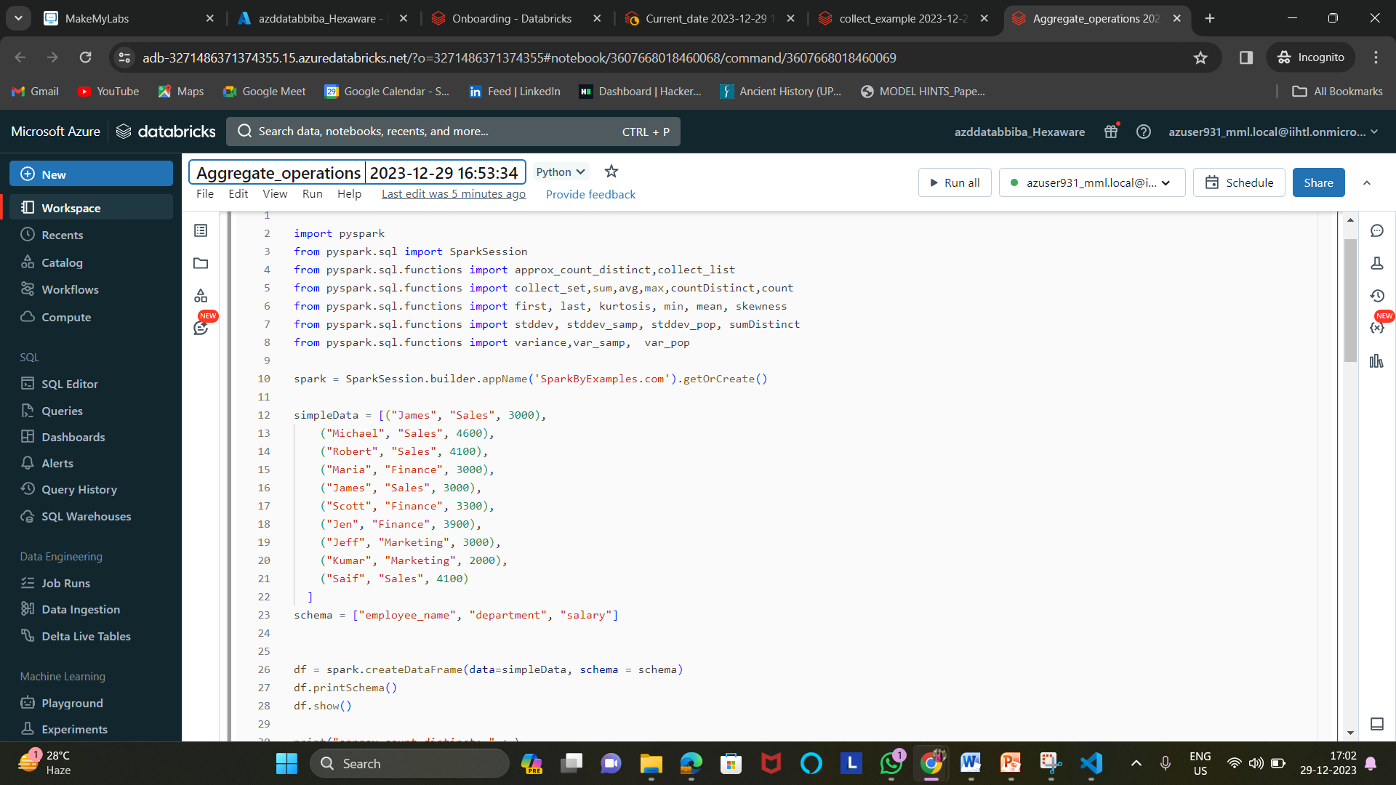

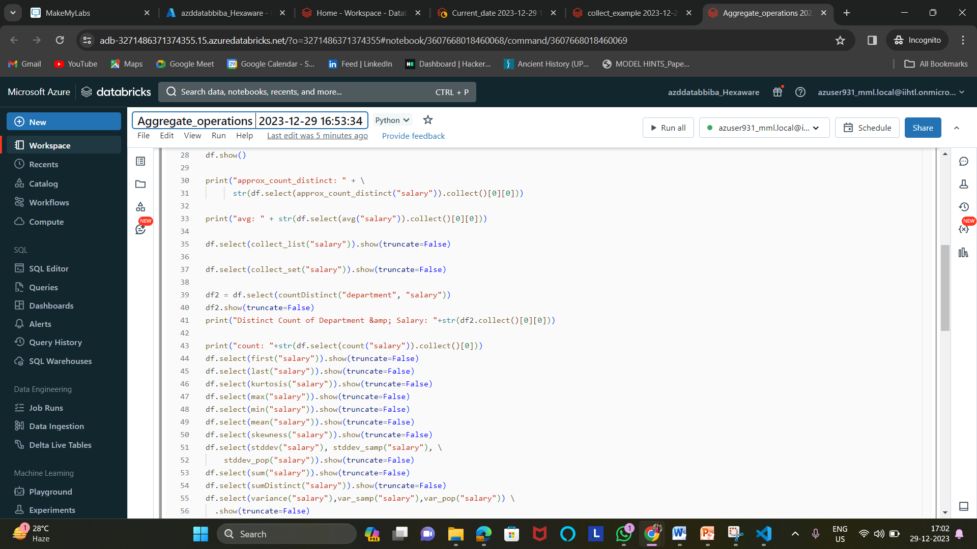

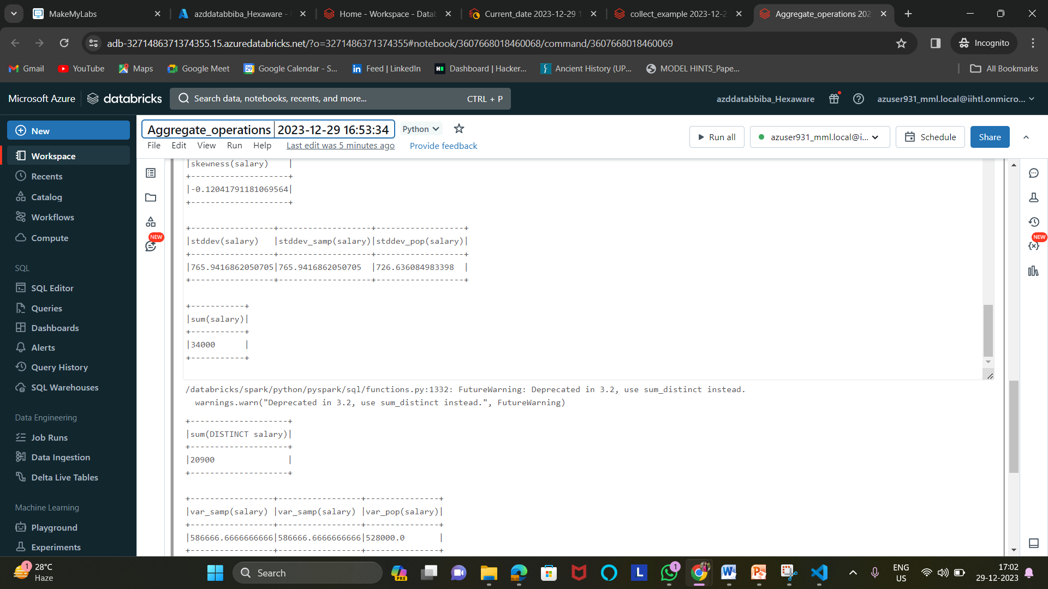

9. Getting Current date

